Combined Chemical Power Plant
Project by Team ANN
Submission Date: 02/09/2019

Shamima Haque Priya
1620069042
Department of Electrical and Computer Engineering
North South University
Dhaka, Bangladesh
Shamima.priya@northsouth.edu

Nabiul Hoque Khandakar
1631164642
Department of Electrical and Computer Engineering
North South University
Dhaka, Bangladesh
nabiul.khandakar@northsouth.edu

Shadman S. Khan
1611918042
Department of Electrical and Computer Engineering
North South University
Dhaka, Bangladesh shadman.khan@northsouth.edu

Ishrat Jahan Ananya
1631636042
Department of Electrical and Computer Engineering
North South University
Dhaka, Bangladesh
ishrat.jahan16@northsouth.edu

Abstract: To maximize the profit from the available megawatt hours, it is essential to predict the complete load electrical production of a base load power plant. This paper examines and distinguishes certain techniques from machine learning to create a predictive model capable of determining a combined cycle power plant's hourly complete electrical power output. A power plant's base load operation is affected by four primary parameters that are used in the dataset as input factors, such as ambient temperature, air pressure, relative humidity, and exhaust vapor pressure. These parameters influence electrical power yield, which is considered as the objective variable. The dataset, which comprises of these info and target factors, was gathered over a six-year time span. In the first place, in light of these factors the best subset of the dataset is investigated among all component subsets in the experiments. Thus, the most efficient technique of machine learning is used to estimate the electrical performance of complete load. Thus, the best achievement of the best subset containing a full set of input factors was noted using the most effective technique, the Random Forest algorithm, with a mean squared error of 0.157 and a Root Mean-Squared Error of 0.373
Keywords—Prediction of electrical power output, combined cycle power plants, Machine learning methods

Introduction
A large number of hypotheses are needed to account for the unpredictability in the solution for accurate system analysis with thermodynamic approaches. Without these hypotheses, a thermodynamic analysis of a real application compels thousands of nonlinear equations whose solution is either nearly impossible or requires too much computational time and effort. The most prevalent issue investigated in machine learning is predicting a real value, known as regression. For this purpose, algorithms for machine learning are used to regulate a system's reaction to predict a numerical or real-valued target function. Many real-life issues can be solved as regression issues and assessed to create predictive models using machine learning methods. [5]
This paper deals with several methods of machine learning regression for a thermodynamic system forecast assessment, which is a combined cycle energy plant (CCPP) with two gas turbines, one steam turbine, and two heat recovery systems. For the efficiency and financial operation of a power plant, it is essential to properly estimate the complete load electrical production of a base load power plant. It is helpful to maximize revenue from the megawatt hours available (MW h). [2, 3]
With regards to power plants, a reliable predictive model for the net energy yield of the following day (complete load electrical power output) per hour needs to be developed using a real-established target function.
The aim of this research is to verify and experiment various methods which is used to obtain the predictive model that will predict the electrical output power (EP) of combined cycle power plant and to see the changes that the model will receive for the attributes present in the data set.

Background
The method of converting energy into electrical power in a gas includes creating mechanical work, which is then converted by a generator into electrical power. The general effectiveness of this transformation can be as small as 30% depending on the fuel type and thermodynamic method.
The system is composed of gas and steam turbines and a heat recovery steam generator. In a CCPP, gas and steam turbines combine electricity in one cycle and are transmitted from one turbine to another. This type of power plant is increasingly being built around the globe, where significant amounts of natural gas are available.
In another work [14], it was stated that an ideal CCPP should have a general capacity of 480 MW, 2 X 160MW ABB 13E2 Gas Turbines, 2 X dual pressure Heat Recovery Steam Generators (HRSG) and 1 X 160MW ABB Steam Turbine.
Combined heat and power plant or Cogeneration plant integrates in one single production of both usable heat (thermal energy) and electricity. The CHP innovation is normally found where there is a requirement for both warm vitality and power where it very well may be utilized for space warming; cooling; household heated water and modern procedures.
In a recent paper [8], it was stated that in Bangladesh, the vast majority of the power plants pursue the strategy of single cycle. As we realize that, the most recent power age introduced limit in Bangladesh is more than 10,000 MW and it will be expanded if the single cycle power plants can be changed over into the join cycle power plants. The procedure for changing over the synthetic vitality of fuel into power includes the production of mechanical vitality, which is at that point changed into electrical vitality by a generator. Depending on the fuel type and thermodynamic procedure, the generally speaking productivity of this transformation can be as low as 30% for the single cycle. This implies 66% of the inert vitality of the fuel being wasted. A joined cycle power plant creates high power yields at high efficiencies (up to 55%) what's more, with low outflow. In a traditional single cycle control plant we are getting 33% of the info vitality into electrical vitality just and the staying 67% is squandered. By utilizing joined cycle power plant this 33% is improved up to 68%.
More as of late, as basic cycle efficiencies have improved and as common gas costs have fallen, gas turbines have been more broadly embraced for base stack power generation, particularly in combined cycle mode, where waste heat is recouped in squander warm boilers, and the steam utilized to produce extra power.

Dataset description
The dataset contains 9568 data points collected from a combined cycle power plant over a 6 year time period (2006-2011) when the power plant was set to be fully charged. Features consist of hourly ambient variables Temperature (T), ambient pressure (AP), relative humidity (RH) and exhaust vacuum (V) to predict the plant's net hourly power production (EP). A combined cycle power plant (CCPP) consists of gas turbines (GT), steam turbines (ST) and steam generators for heat recovery.[7]

In a CCPP, the power is created by gas and steam turbines, which are joined in one cycle, and is moved starting with one turbine then onto the next. While the Vacuum is gathered from and has impact on the Steam Turbine, the other three of the surrounding factors impact the GT execution. For equivalence with our gauge examines, and to permit 5x2 fold statistical tests to be completed, we rearrange the data multiple times. For each rearrangement 2-fold CV is done and the subsequent 10 estimations are utilized for statistical testing.

Features consist of hourly average ambient variables:

Temperature (T) | in the range 1.81°C and 37.11°C, (input) -(data에서 AT)
Ambient Pressure (AP) | in the range 992.89-1033.30 milibar, (input)
Relative Humidity (RH) | in the range 25.56% to 100.16% (input)
Exhaust Vacuum (V) | in the range 25.36-81.56 cm Hg (input)
Net hourly electrical energy output (EP) 420.26-495.76 MW. | The averages are taken from various sensors located around the plant that record the ambient variables every second. The variables are given without normalization. (Output)
Table 1: Features of the datasets

To deduce some initial findings from the dataset we decided to do data visualization to determine the inputs and outputs of the given dataset and to really understand and comprehend the situations that needs to be understood to get conclusive results. Below are some of the illustrations that helped us in visualizing the dataset [Figure 1, Figure 2, and Figure 3]:

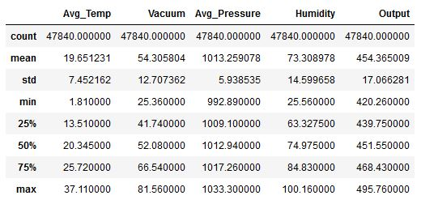
Figure 1: Statistical overview of dataset

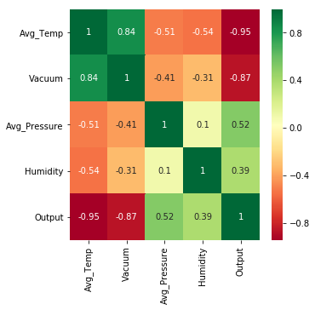
Figure 2: Correlation Heat-map
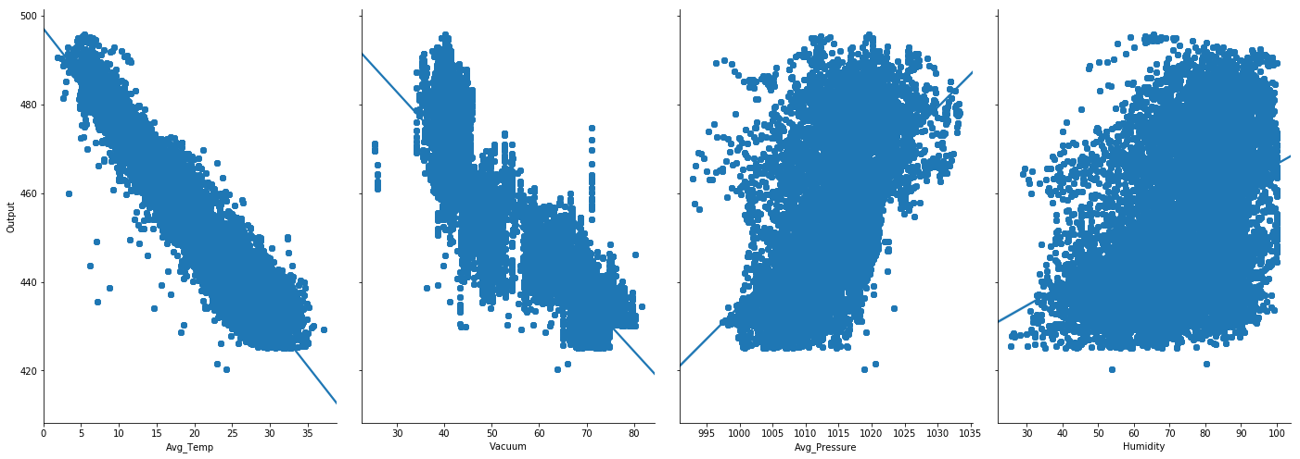
Figure 3: Feature Pair-plots

From the above illustrations, it can be deduced that the features, Average Temperature and Vacuum are likely to be the more important features from the dataset. The Correlation Heat-map and the pair-plots shows a strong correlation of the features with the predictive output.

IV. Methodology
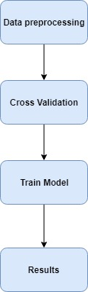
Figure 4: Methodology flowchart
There are two primary purposes in this research for this assignment. First is to determine the best subset of the data set, which provides the highest predictive precision with a mixture of the input parameters specified for gas and vapor turbines such as ambient temperature, vacuum, atmospheric pressure, and relative humidity. The outcomes of the predictive accuracies for the various combinations of the parameters were then compared and assessed to determine the best subset of the dataset. This paper compared the predictive precision of regression methods as the second purpose, which was found to be the most successful regression method in predicting full load electrical power output of a base load operated CCPP with the highest predictive precision. [14]
The mentioned methodology was followed to train the data and formulate the results to calculate the output for the combined cycle power plant.
IV. Data Preprocessing:

A. Handling Missing Values:
With any dataset it is important that the data must be refined to reduce the noise in the overall dataset to ensure the best prediction possible. With that under consideration, a function was carried out that chose the missing (NaN) values in data points and replaced it with the mean value of the column for which the data stays consistent.
B. Steps that were not considered:
- Feature Selection
Since the dataset contained only just 5 features to predict the output, it was ideal not to use any feature selection is to filter the features
- Scaling
All the units on the features are adequately scaled. Hence, it was not ideal to perform scaling on any of the features.
C. Steps performed:
- Cross Validation
Cross validation (CV) is one of the machine learning techniques which is used to test the effectiveness of a predictive model. It is also a re-sampling procedure used to evaluate a model if the dataset is constrained or contains limited set of data. In order to perform cross validation, the dataset is divided into two sections. Train and test. The latter set of data is then used for testing.
For cross-validation of the models that was implemented, K=5 Fold CV was used which segregated the dataset into 5 portions for validation. For the regular Train/Test split, the scikit-learn library was used that provided the method “train_test_split” for splitting into train and test data sets. In this approach, the dataset was split randomly 5 times into X train set, Y train set, X test set and Y test set. Ideally, the data was split into the 70:30

V. Models
- Multivariate Linear Regression
The most simple and precise algorithm consists of multivariate linear regression. In fact, a multivariate regression is multiple regression where we have one dependent variable i.e. output variable and several independent variables (predictors).Based on a number of predictors, the output variable was predicted. The linear equation of the regression model is as follows:
y = 454.6093 + (-1.9775)*Average_Temperature + (-0.2339)*Vacuum + 0.06214*Avg_Pressure + (-0.1581)*Humidity

- Support Vector Regression
Support Vector Machine can also be used as a regression method, keeping up all the fundamental highlights that portrays the calculation (maximal edge). The Support Vector Regression (SVR) utilizes indistinguishable standards from the SVM for grouping, with just a couple of minor contrasts. Firstly, as the output is a real number it turns out to be extremely hard to anticipate the data at present, which has boundless conceivable outcomes. On account of regression, a margin of tolerance (epsilon) is set in estimate to the SVM which would have effectively mentioned from the issue. Besides this fact, there is a greater confused reason and the calculation is increasingly complicated thus it must be taken in consideration. However, the principle thought is consistently the same which is to limit errors, individualizing the hyperplane that amplifies the edge, remembering that part of the error is tolerated.
- Random Forest Regression
Random forests are made of many decision trees. They are sets of decision trees, each decision tree generated through the use of a subset of characteristics used to classify a specified population (they are sub-trees). The decision trees vote on how to classify input information in a specified example, and the random forest bootstraps votes to select the best forecast. This is performed to avoid a prevalent decision trees fitting, a prevalent flaw. We tested a peak cap of 50 trees in our model.

VI. Results and Evaluation
The predicting accuracy of each machine learning regression method is used to evaluate the overall comparison between actual and predicted values. In this case, it was decided to evaluate the prediction accuracy by using the following performance criteria such as R2, Mean Squared Error (MSE) and Root Mean Squared Error (RMSE) for continuous variables.

- R2 Score
R-squared (R2) is a statistical measure representing the ratio of variance to a dependent variable that is explained in a regression model by an independent variable or variables. While correlation describes the power of the connection between an autonomous and dependent variable, R-squared explains the extent to which one variable's variance explains the second variable's variance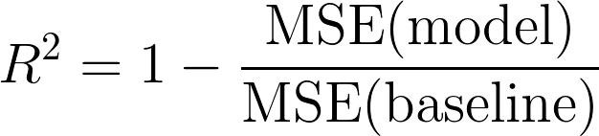
Figure 5: R-Squared Equation
- MSE
MSE basically measures our predictions ' average square mistake. It calculates the square gap between the projections and the target for each point and then averages those values. It is never negative, as we square the individual predictive mistakes before summing them, but for a ideal model, it would be zero.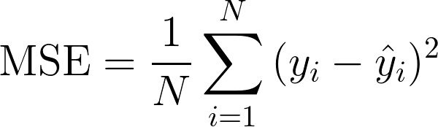
Figure 6: Mean Squared Error Equation
- RMSE
RMSE is a quadratic scoring rule which also measures the error's average size. It is the square root of the square average difference between forecast and real observation.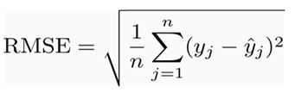
Figure 7: Root Mean Squared Error Equation

We obtain the following outcomes after effectively operating the information through the aforementioned models. It is worth noting that we ran the model for the Random Forest Regressor for a total of 3 times for distinct amount of trees as stated below [Table 2]:
Models | CV Accuracy  R2 with K=5 | Test Accuracy  R2 | Test Accuracy  MSE | Test Accuracy  RMSE
Linear Regression | 0.928696089 | 0.925614418 | 21.63156049639472 | 4.650974144885641
Random Forest  Trees = 10 | 0.999769605 | 0.9994886256938644 | 0.14746131929347708 | 0.3640069261003125
Random Forest  Trees = 50 | 0.999859245 | 0.9994886256938644 | 0.14746131951247708 | 0.3740069261022395
Random Forest  Trees = 100 | 0.999869605 | 0.9994886256938644 | 0.15746131612347708 | 0.3731569261009195
Support Vector Regression | 0.883532012 | 0.8679460774633871 | 38.70546904453775 | 6.221371958381668
Table 2: Different methods with predictive results

To illustrate the accuracies visually, scatter plots have been generated to show how close the Predicted Values from each algorithm came close to its respective True Values.
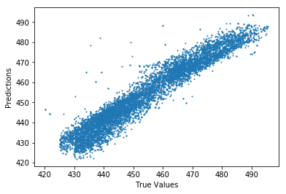
Figure 8: Linear Regression Predictions
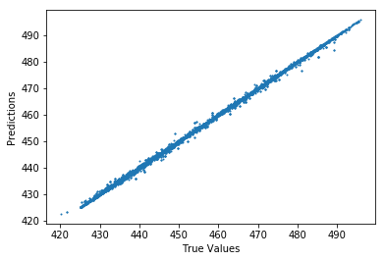
Fig 9: Random Forest Predictions
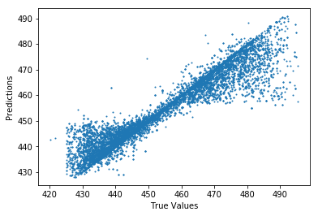
Fig 10: Support Vector Regression Predictions

VII. Discussion
From the results we obtained, we can deduce that the algorithm that has given the best performance would be Random Forest with a peak accuracy of 99% in almost all of the three variations with 10, 50 and 100 trees. The increment of trees only resulted in a very insignificant change of accuracy [Figure 12].
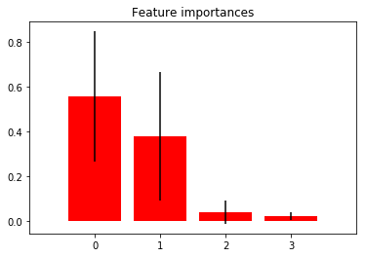Fig 11: Random Forest Feature Importance
The feature importance bar chart also hints at the assumptions being true when the data was visualized to conclude that the features Average Temperature (Bar 0) and Vacuum (Bar 1) in Fig 11 seems to be highly important in predicting the Output.
The Linear Regression performed well in predicting the values and came out as the most resource efficient and easy to interpret algorithm in the selected range.
It can be observed that the algorithm with the least accuracy would be Support Vector Regression. Possible reason for such performance might be due to the kernel function being used to transform the dimensionality of the data. It is always a formidable task when generating such hyperplanes as the one conducted in the Support Vector Regression performed with the non-linear data.

VIII. Conclusion
More Data: As with any other Machine Learning model, the more the data, the more better accurate results. In our case, the sample of data collected were of just 6 years. 10+ years of collected data may have had a better impact and would have helped us to derive better predictions.
Poor features: A vital drawback of the dataset that is not possible to ignore which is we worked with just 4 numerical features. It would have yielded more realistic results if there were more useful numeric/categorical feature available at hand.
We intend to perfect the input to this predictive model in future works by first anticipating more accurately the ambient variables of the next day, and also investigating predictions of electrical power output for various kinds of power plants.

Acknowledgments
Finally, we would like to thank our faculty and our course supervisor, Mirza Mohammad Lutfe Elahi, who is currently a senior lecturer at the department of electrical and computer engineering at North South University, Dhaka, for his constant supervision, support and help.

References

- "Combined-Cycle Power Plant – How it Works | GE Power Generation", Ge.com, 2019. [Online]. Available: https://www.ge.com/power/resources/knowledge-base/combined-cycle-power-plant-how-it-works. [Accessed: 01- Sep- 2019].

- E. Elfaki and A. Ahmed, "Prediction of Electrical Output Power of Combined Cycle Power Plant Using Regression ANN Model", Journal of Power and Energy Engineering, vol. 06, no. 12, pp. 17-38, 2018. Available: 10.4236/jpee.2018.612002.

- E. Ersayin and L. Ozgener, "Performance analysis of combined cycle power plants: A case study", Renewable and Sustainable Energy Reviews, vol. 43, pp. 832-842, 2015. Available: 10.1016/j.rser.2014.11.082.

- Gari, J., Jr, F., Oozeki, T., Takashima, T., & Koshimizu, G. (2011). Use of support vector regression and numerically predicted cloudiness to forecast power output of a photovoltaic power plant in Kitakyushu , Japan. URL https://doi.org/10.1002/pip

- H. Altay Guvenir and I. Uysal, "Regression on feature projections", Knowledge-Based Systems, vol. 13, no. 4, pp. 207-214, 2000. Available: 10.1016/s0950-7051(00)00060-5.[Accessed 1 September 2019].

- J. da Silva Fonseca, T. Oozeki, T. Takashima, G. Koshimizu, Y. Uchida and K. Ogimoto, "Use of support vector regression and numerically predicted cloudiness to forecast power output of a photovoltaic power plant in Kitakyushu, Japan", Progress in Photovoltaics: Research and Applications, vol. 20, no. 7, pp. 874-882, 2011. Available: 10.1002/pip.1152.

- "makinarocks/awesome-industrial-machine-datasets", GitHub, 2019. [Online]. Available: https://github.com/makinarocks/awesome-industrial-machine-datasets/tree/master/data-explanation/Combined%20Cycle%20Power%20Plant?fbclid=IwAR2Gy8XaHHBNkBMIjAPjTYqsZMkPg5Us3_kGl_1pYGN3Zo_hg-Y3azG-47Y.
[Accessed: 01- Sep- 2019].

- M. Hossain, I. Zissan, M. Khan, Y. Tushar and T. Jamal, "Prospect of combined cycle power plant over conventional single cycle power plants in Bangladesh: A case study", 2014 International Conference on Electrical Engineering and Information & Communication Technology, 2014. Available: 10.1109/iceeict.2014.6919060 [Accessed 1 September 2019].

- M. Zamo, O. Mestre, P. Arbogast and O. Pannekoucke, "A benchmark of statistical regression methods for short-term forecasting of photovoltaic electricity production, part I: Deterministic forecast of hourly production", Solar Energy, vol. 105, pp. 792-803, 2014. Available: 10.1016/j.solener.2013.12.006.

- M. Soulouknga, S. Doka, N.Revanna, N.Djongyang and T.C.Kofane, "Analysis of wind speed data and wind energy potential in Faya-Largeau, Chad, using Weibull distribution", Renewable Energy, vol. 121, pp. 1-8, 2018. Available: 10.1016/j.renene.2018.01.002.

- Tüfekci, "Prediction of full load electrical power output of a base load operated combined cycle power plant using machine learning methods", International Journal of Electrical Power & Energy Systems, vol. 60, pp. 126-140, 2014. Available: 10.1016/j.ijepes.2014.02.027.

